Project #3: Visualizing Data

Report

NayLawEhHtoo
Department of Civil & Environmental Engineering, University of Nebraska-Lincoln
CIVE 202: Civil Engineering Analysis II
Dr. Kaycie Lane
February 3, 2026

Table of Contents
Project #3: Visualizing Data 1
Report 1
Introduction/Background 3
Methods 3
Method 1: Clean Data 3
Method 2: Variables Picked & Why 3
Method 3: Creating & Customizing Plots 4
Method 4: IDM Simulation 5
Results & Discussion 6
Result 1: Number of Vehicles by Type in NHTS Survey 6
Result 2: Distribution of Vehicle Age 7
Result 3: Vehicle Age Distribution: Census Region 8
Result 4: Vehicle Speed Comparison (Trajectory #8) 9
Result 5: Vehicle Acceleration Comparison (Trajectory #8) 10
Result 6: Validation: Comparison of Real-World vs. Simulated Trajectories 11
References 12

Introduction/Background
The Federal Highway Administration (FHWA) uses detailed data to improve transportation systems. This project analyzes the National Household Travel Survey (NHTS) for broad travel trends and the Next Generation Simulation (NGSIM) for detailed driving behavior. As the lead engineering intern, I transformed complex datasets into clear visuals to support transportation planning decisions. The project's main objective is to create advanced data visualizations such as categorical bar charts, distribution histograms, and time-series plots to showcase key trends in U.S. travel. Additionally, it will simulate follower-vehicle acceleration using the Intelligent Driver Model (IDM) to compare theoretical trajectories with real-world NGSIM data. This work aims to demonstrate to the Professional Engineer (PE) that switching from Excel to a Python-based workflow enhances analytical depth, simulation accuracy, and long-term efficiency for the firm.

Methods
The annotated coding document is also available for line for line coding and explanation. To ensure results are replicable by other analysts, the following methods will be explained using Python within a Jupyter Notebook. These are the steps I took to show that my steps are replicable. I used Python libraries like pandas, matplotlib, and seaborn to clean the data and build the charts.

Method 1: Clean Data
The NHTS file needed most of the cleaning. There were empty spaces or missing values and duplicates. The empty spaces and duplicates were filtered out. NGSIM, however, was basically already cleaned.

Method 2: Variables Picked & Why
I chose these specific variables because they will help us understand the bigger picture of travel in the US and the smaller details of how cars drive.
Vehicle type
This data comes from the NHTS dataset. I chose this variable so that we can see which kind of vehicles are most common. This helps planners identify which vehicle classes dominate the infrastructure, such as SUVs vs. traditional automobiles (AASHTO). This type of data will be plotted as a Bar chart.
Vehicle age
This data comes from the NHTS dataset. I chose this variable because it shows the age of the cars on the road, which helps with safety and pollution planning. A peak in older vehicles might indicate a need for more stringent emission testing or safety inspections in certain regions (EPA). This type of data will be plotted using a histogram.
Vehicle age vs Census region.
This data comes from the NHTS dataset. I chose these variables to see if people in different parts of the country drive older or newer cars. It helps identify if certain regions have significantly older fleets, which can impact regional transportation policy and safety planning (NHTSA). This type of data will be plotted as a box plot.
Speed - Leader vs. Follower
This data comes from the NGSIM dataset. I chose this variable to keep track of how the car’s speed changes second by second during the drive. It allows you to see the reaction time (the time lag between when the leader slows down and when the follower responds) and speed synchronization. This type of data will be plotted as a time series.
Acceleration - Leader vs. Follower
This data comes from the NGSIM dataset. I chose this variable to see how hard a driver is breaking or hitting the gas pedal over time. It shows "acceleration noise" (Drew). You can see if the follower is over-reacting (braking harder than the leader) or under-reacting. This type of data will be plotted as a time series.

Method 3: Creating & Customizing Plots
Building the Charts: For each different type of chart. Most of the coding was similar, except for the type of chart.
Bar Chart: I used the NHTS dataset. This plot uses Seaborn and Matplotlib to create a horizontal bar chart showing the frequency of vehicle categories in the NHTS dataset. It sets up a 12x6 inch figure and employs the sns.countplot function to display occurrences for each vehicle type along the y-axis, sorted in descending order with the "viridis" color palette. Descriptive bold labels and a large title are added for clarity before optimizing the layout and displaying the chart.
Histogram: I used the NHTS dataset. This plot uses a histogram to show the distribution of vehicle ages. It sets a 12x6 inch canvas and groups the data into 20 bins using plt.hist(). The bars have a teal fill with 40% transparency, black edges for distinction, and bolded axis labels with a large title for clarity. The tick mark font size is adjusted for better readability.
Box Plot: This plot displays data from a categorical variable (census region) and a numerical variable (vehicle age) using a box plot to compare vehicle age distributions across regions. The box represents the interquartile range (middle 50% of data), while the horizontal line shows the median age for each region. The "whiskers" indicate the rest of the distribution, and points beyond them typically represent outliers. Using the "Set2" color palette and bold axis labels, the visualization helps identify trends in vehicle age across different regions.
Time Series Plot 1: I used NGSIM data. I filtered the data to focus on a specific trajectory (Trajectory #8) and mapped Time to the x-axis and speed to the y-axis, creating a time-series line plot comparing the speeds of a leader and follower vehicle. The plot uses a dashed line for Leader Speed and a solid red line for Follower Speed, making it effective for analyzing driving behavior, such as how the follower responds to the leader’s actions and any lag in reaction times.
Time Series Plot 2: I used NGMSIM data to generate a dual-line plot showing the acceleration and deceleration of a leader and follower vehicle over time, focusing on Trajectory #8. The Leader Acceleration is a dashed green line, serving as a baseline, while the Follower Acceleration is a solid orange line. This visualization helps identify "string instability" in traffic, revealing how much more aggressively the follower brakes compared to the leader and any delays in their response.

Method 4: IDM Simulation
To stimulate how cars drive, we used the Intelligent Driver Model. It is a mathematical rule that tells the following car how to drive based on the leading car. Taking the real speed and position of the leader car from the NGSIM data. I then used the IDM formula to calculate how a computer-controlled car would react. By comparing the "robot driver" to the real driver in the data, we can see how safe or efficient the real-world driving behavior was.
To create a traffic simulation using the Intelligent Driver Model (IDM), the idm_acceleration function is defined to calculate a safety gap based on time headway (T) and comfortable braking (b). The simulation utilizes a real-world driving sequence (Trajectory #8) from the NGSIM dataset as "ground truth." A loop updates the simulated follower's speed and position every 0.1 seconds according to the leader's movements. Finally, a validation plot displays the actual leader, the actual follower, and the IDM-simulated follower, allowing for a visual assessment of the model's accuracy.

Results & Discussion

Result 1: Number of Vehicles by Type in NHTS Survey
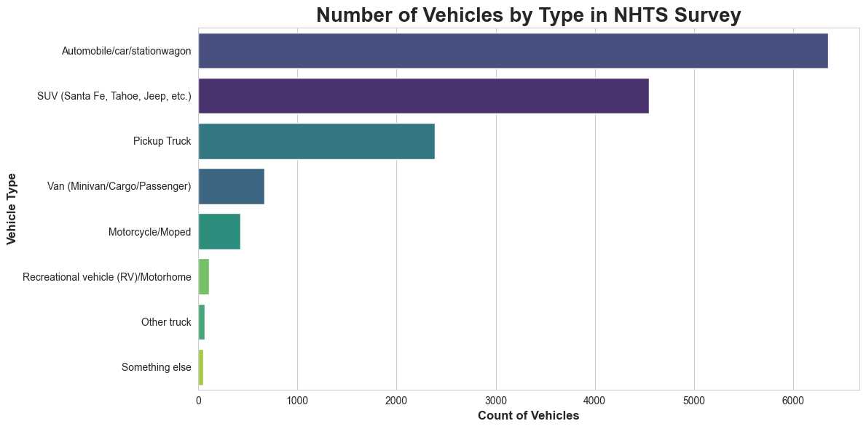
Figure 1- Plot 1
The bar chart from the National Household Travel Survey (NHTS) shows that vehicle ownership is led by Automobiles (over 6,000 units), followed by SUVs and Pickup Trucks, while RVs and motorcycles make up a small portion. This data highlights a consumer preference for larger, multi-purpose vehicles, indicating that infrastructure and fuel demands will prioritize high-occupancy vehicles. Additionally, the significant gap between traditional cars and alternatives suggests that the industry needs to focus on the existing fleet of standard passenger vehicles to effectively address emissions and traffic management.

Result 2: Distribution of Vehicle Age
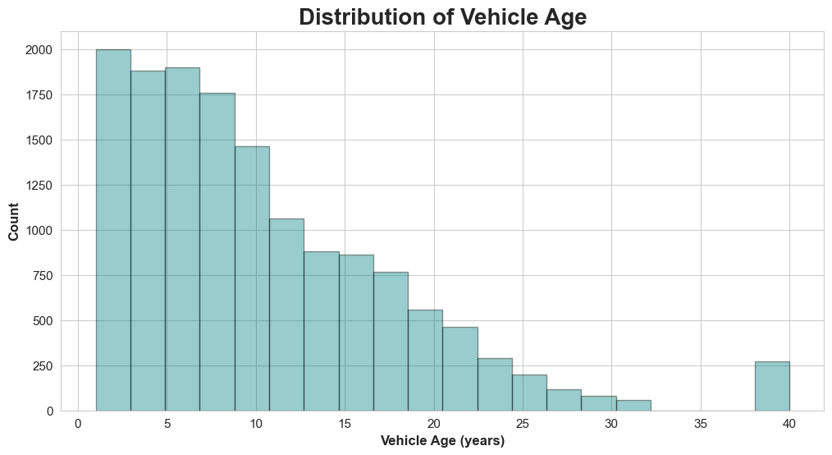
Figure 2- Plot 2
The histogram shows a right-skewed distribution of vehicle age, with most vehicles being relatively young, peaking between 1 and 10 years, and a gradual decline as age increases. A notable "long tail" extends past 30 years, with a small spike at 40 years, likely indicating vintage or classic vehicles. This suggests a slow fleet turnover rate; many vehicles are still 10–20 years old. Thus, while new, efficient vehicles are emerging, innovations in safety and emissions standards take time to penetrate the market, challenging policymakers and manufacturers to address the needs of an aging fleet.

Result 3: Vehicle Age Distribution: Census Region
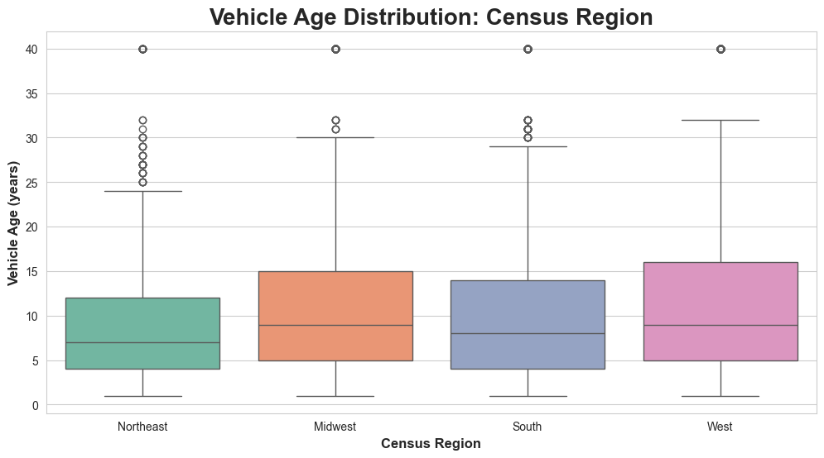
Figure 3- Plot 3
This boxplot comparing Vehicle Age Distribution by Census Region shows that the Northeast has the youngest vehicle fleet, with the lowest median and interquartile range. In contrast, the West and Midwest have older vehicles, with the West showing the most variability between new and old models. These regional differences are important for business strategies: the Northeast indicates a stronger market for new car sales and tech adoption, likely due to harsher weather. Meanwhile, the West and Midwest's older fleets suggest a higher demand for aftermarket parts and maintenance services.

Result 4: Vehicle Speed Comparison (Trajectory #8)
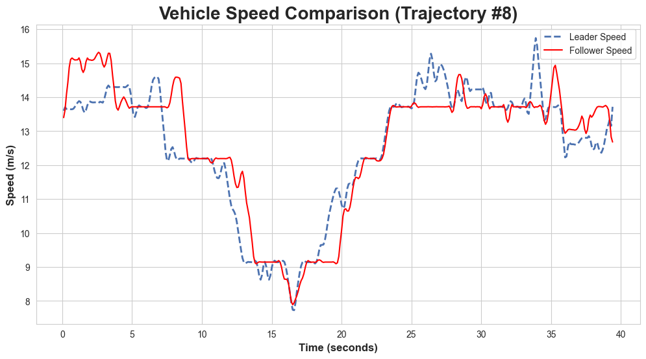
Figure 4- Plot 4
The Vehicle Speed Comparison plot depicts a classic car-following scenario where the "Follower" (red line) seeks to match the "Leader" (dashed blue line). A key finding is that the follower exhibits a time lag and smoother speed profile, reacting with a delay to the leader's sharp deceleration (around 12 seconds) or acceleration (around 18 seconds). This data is crucial for the transportation industry in developing Adaptive Cruise Control (ACC) and Autonomous Vehicle (AV) algorithms, as it quantifies necessary reaction times for safety. Understanding these behaviors can help reduce "traffic waves" and improve fuel efficiency by smoothing out speed fluctuations.

Result 5: Vehicle Acceleration Comparison (Trajectory #8)
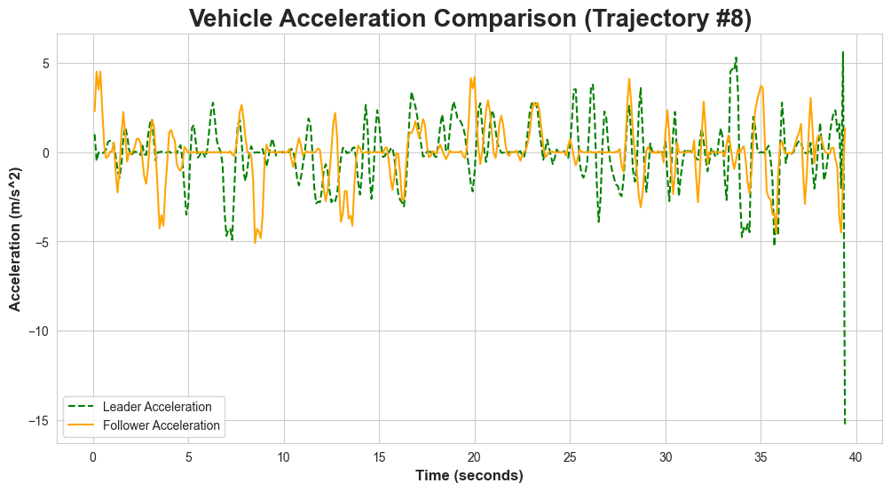
Figure 5-Plot 5
This Vehicle Acceleration Comparison plot demonstrates the dynamic nature of driver behavior in car following. A key observation is the "noise" of human control, with both vehicles showing rapid fluctuations in acceleration and deceleration instead of smooth transitions. The follower (solid orange) generally tracks the leader's (dashed green) trends, but with a phase lag and slight damping effect. A critical moment occurs at the end of the trajectory, where the leader executes a sharp deceleration of about -15 m/s², simulating a hard braking event that tests following distance and reaction time. These findings are vital for the transportation industry, as high-frequency oscillations impact passenger comfort and fuel efficiency. They drive the development of predictive cruise control to smooth transitions and enhance energy efficiency. Additionally, the extreme deceleration data is crucial for calibrating Automatic Emergency Braking (AEB) and Forward Collision Warning (FCW) systems, ensuring quicker reactions than human drivers to prevent rear-end collisions.

Result 6: Validation: Comparison of Real-World vs. Simulated Trajectories
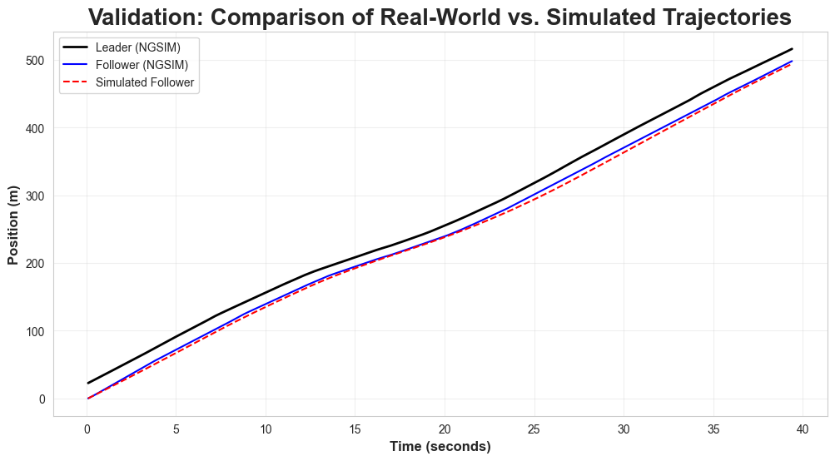
Figure 6- Plot 6
The Validation: Comparison of Real-World vs. Simulated Trajectories plot demonstrates high accuracy in modeling vehicle behavior, with the Simulated Follower (dashed red line) closely tracking the Real-World Follower (solid blue line) over 40 seconds. The simulation effectively captures gap-keeping behavior, maintaining a consistent distance behind the Leader (black line) despite changes in speed. This validation is crucial for the transportation industry as it shows that digital twin simulations can reliably predict human driving patterns, enabling safe testing of Autonomous Vehicle (AV) software and traffic management strategies in virtual environments. By accurately reflecting real-world trajectories, companies can minimize costs and risks associated with physical road testing while ensuring safe interactions with human drivers.

References
United States, Department of Transportation, Federal Highway Administration (NGSIM). Next Generation Simulation (NGSIM) Vehicle Trajectories. Office of Operations, 2006, https://ops.fhwa.dot.gov/trafficanalysistools/ngsim.htm.
United States, Department of Transportation, Federal Highway Administration (NHTS). 2022 National Household Travel Survey. Oak Ridge National Laboratory, 2022, https://nhts.ornl.gov/.
American Association of State Highway and Transportation Officials (AASHTO). AASHTO Guide for Design of Pavement Structures. 4th ed., AASHTO, 1993. https://store.transportation.org/
Environmental Protection Agency (EPA). MOVES3 (Motor Vehicle Emission Simulator) User Guide. EPA-420-B-20-044, Nov. 2020. https://www.epa.gov/moves/latest-version-motor-vehicle-emission-simulator-moves
National Highway Traffic Safety Administration (NHTSA). The Critical Need for Automated Emergency Braking (AEB) in Passenger Vehicles. U.S. Department of Transportation, 2017. https://www.nhtsa.gov/technology-innovation/automated-vehicles-safety
Drew, Donald R. Traffic Flow Theory and Control. McGraw-Hill, 1968. https://rosap.ntl.bts.gov/view/dot/1335

